Holy Trinity Evangelical Lutheran Church

21st Sunday After Pentecost

October 18 2026, at 10:30 am

Pastor Tina Crog

*Prelude

* Welcome and Announcements Worship Assistant

*Call to Worship Pastor Tina
The Lord Jesus Christ is our shepherd.
He lays down his life for his sheep.
The Lord Jesus Christ is our shepherd.
He knows us, and we belong to him.
The Lord Jesus Christ is our shepherd.
He speaks, and we listen for his voice.

*Opening Hymn "My Shepherd, You Supply My Need" ELW 782
Public Domain
1.My Shepherd, you supply my need; most holy is your name. In
pastures fresh you make be feed, beside the living stream. You
bring my wand’ring spirit back when I forsake your ways, and lead me, for your mercy’s sake, in paths of truth and grace.

2.When I walk through the shades of death, your presence is my stay; one word of your supporting breath drives all my fears away. Your hand, in sight of all my foes, does still my table spread; my cup with blessings overflows, your oil anoints my head.

3.The sure provisions of my God attend me all my days; oh, may your house be my abode and all my work be praise. Here would I find a settled rest, while others go and come; no more a stranger or a guest, but like a child at home.

* Confession and Forgiveness Pastor Tina
Blessed be the holy Trinity, ☩ one God, who pours love into our hearts and healing upon the earth. Amen.

Friends, in as much as God is our shepherd, let us not fear, but confess our sin that God may restore our souls.

Holy God, we confess that we have strayed from your paths of right relationship and peace, and we have dishonored you, ourselves, and your creation; we repent of these hurtful ways. Forgive us, we pray, as we learn to forgive others, and guide our feet into the way of peace. Amen.

God’s mercy overflows as a healing spring to cleanse us of our offenses. As a called and ordained minister in the Church of Christ, and by his authority, I therefore declare the entire forgiveness of all of your sins; in the name of the Father, and of the Son, ☩ and of the Holy Spirit. Thanks be to God!

*Greeting Pastor Tina

*Prayer of the Day Worship Assistant
We are your people, O God—the sheep of your pasture, the flock you have gathered. Lead us beside still waters; teach us the way of righteousness; and feed us at your table; through Jesus Christ, our good shepherd. Amen.

*First Lesson: Ezekiel 34:11-16, 23 Reader
¹¹ For thus says the Lord God: I myself will search for my sheep and will sort them out. ¹² As shepherds sort out their flocks when they are among scattered sheep, so I will sort out my sheep. I will rescue them from all the places to which they have been scattered on a day of clouds and thick darkness. ¹³ I will bring them out from the peoples and gather them from the countries and bring them into their own land, and I will feed them on the mountains of Israel, by the watercourses, and in all the inhabited parts of the land. ¹⁴ I will feed them with good pasture, and the mountain heights of Israel shall be their pasture; there they shall lie down in good grazing land, and they shall feed on rich pasture on the mountains of Israel. ¹⁵ I myself will be the shepherd of my sheep, and I will make them lie down, says the Lord God. ¹⁶ I will seek the lost, and I will bring back the strays, and I will bind up the injured, and I will strengthen the weak, but the fat and the strong I will destroy. I will feed them with justice.
²³ I will set up over them one shepherd, my servant David, and he shall feed them; he shall feed them and be their shepherd.
let us be glad and rejoice in his salvation.”

The Word of the Lord. Thanks be to God.

*Silence

*Special Music by Jared Goldinger

*Poem: “The Good Shepherd” by Beverly Joy, 2014 Pastor Tina
Let me tell you a story
From a sheep’s point of view
Come join me in the herd
Of the Good Shepherd.

It is springtime
The shepherd leaves his home
To lead us, his sheep
Away till wintertime.

For some strange reason, God made sheep
Helpless and silly, stubborn and needy
Vulnerable and weak, fearful and skittish
And easily mislead.

We need our shepherd to guide us
We want for nothing that is good for us
Our Good Shepherd cares and protects
He skillfully provides for all our needs.
The Good Shepherd doesn’t provide
Everything that we desire
But what we need when the time is right
We trust him to provide what is best for us.

In open lush fields
Not parched or bare
We safely eat ‘till content
Under his watchful care.

Our Good Shepherd makes us lie down
To rest before we drink
He protects us from stomach pain
We stay safe when us, he restrains.

Sheep will not drink from running water
Nor drink from stagnant dirty water
Our Good Shepherd leads us beside pools still and fresh
Till our thirst is quenched and we feel refreshed.

Sheep will not lie down at the end of the day
And sleep until peace, quiet and comfort reign
When we are restless, He calms us
By walking among us with his rod and staff.

He touches the brow of every sheep
With an oil and herb tonic
That deters flies and parasites from their eyes
Our irritation, hunger and thirst
His care will soothe and satisfy.

Once rested and nourished quiet and content
The shepherd moves his sheep on
He walks ahead to entice us
To follow him faithfully along the right path.

The Good Shepherd checks the terrain
And prepares it for grazing
Prickles that bruise our skin and hooves
And poisonous plants, he removes
We live under His watchful eye in banquet style.

The shepherd returns us to our feet
When we fall and can’t right ourselves
When caught in bushes we cry out for help
Getting scratched and tangled as we thrash about.

He secures the herd and then starts his search
For the sheep who wandered off the right path
He’s determined to find us; he pulls us free
With strength, he rescues His precious lost sheep.

We trust Him to rescue,
Love and forgive us
For, we both know
That as sheep, we can’t save ourselves.

The shepherd carries his rod and staff
To protect from lions, bears, and predators
That spy and stalk us night and day
From hidden places along the way.

As winter approaches the shepherd leads us home
Down from high places into treacherous valleys
Where shadows steal sunlight
Miserable and frightening.

Our despair is soothed
Our hope renewed
For His staff and his rod
We keep in view.

The Good Shepherd promises
To lead us through
To comfort and safety
Back to our home.

His voice assures
“Do not fear, I am here,
Nothing can separate you from my love.”

Contented we bask
In his goodness and mercy
His unceasing love, favor,
Acceptance, compassion.

He claims ownership,
He has chosen us
Despite our dependence
And our helplessness.

The LORD is my shepherd
Hallelujah.

*Second Lesson: Isiah 40:1-11 Reader
¹ Comfort, O comfort my people,
says your God.
² Speak tenderly to Jerusalem,
and cry to her
that she has served her term,
that her penalty is paid,
that she has received from the Lord’s hand
double for all her sins.
³ A voice cries out:
“In the wilderness prepare the way of the Lord;
make straight in the desert a highway for our God.
⁴ Every valley shall be lifted up,
and every mountain and hill be made low;
the uneven ground shall become level,
and the rough places a plain.
⁵ Then the glory of the Lord shall be revealed,
and all flesh shall see it together,
for the mouth of the Lord has spoken.”
⁶ A voice says, “Cry out!”
And I said, “What shall I cry?”
All flesh is grass;
their constancy is like the flower of the field.
⁷ The grass withers; the flower fades,
{{when the breath of the Lord blows upon it;
surely the people are grass.
⁸ The grass withers; the flower fades,}}
but the word of our God will stand forever.
⁹ Get you up to a high mountain,
O Zion, herald of good news;
lift up your voice with strength,
O Jerusalem, herald of good news;
lift it up, do not fear;
say to the cities of Judah,
“Here is your God!”
¹⁰ See, the Lord God comes with might,
and his arm rules for him;
his reward is with him
and his recompense before him.
¹¹ He will feed his flock like a shepherd;
he will gather the lambs in his arms
and carry them in his bosom
and gently lead the mother sheep.
The Word of the Lord. Thanks be to God.

*Silence

*Special Music "Shepherd Me, O God" ELW 780 One License A-700000 Pastor Tina & Jared Goldinger

* Third Reading: John 10:1-10 Pastor Tina
¹ “Very truly, I tell you, anyone who does not enter the sheepfold by the gate but climbs in by another way is a thief and a bandit. ² The one who enters by the gate is the shepherd of the sheep. ³ The gatekeeper opens the gate for him, and the sheep hear his voice. He calls his own sheep by name and leads them out. ⁴ When he has brought out all his own, he goes ahead of them, and the sheep follow him because they know his voice. ⁵ They will not follow a stranger, but they will run from him because they do not know the voice of strangers.” ⁶ Jesus used this figure of speech with them, but they did not understand what he was saying to them.
⁷ So again Jesus said to them, “Very truly, I tell you, I am the gate for the sheep. ⁸ All who came before me are thieves and bandits, but the sheep did not listen to them. ⁹ I am the gate. Whoever enters by me will be saved and will come in and go out and find pasture. ¹⁰ The thief comes only to steal and kill and destroy. I came that they may have life and have it abundantly.

The Word of the Lord. Thanks be to God.

*Silence

*Special Music “Unfailing Love” Soloist, Amy Hartline
1981 Hope Publishing Company

* Fourth Reading John 10:11-16 Pastor Tina
¹¹ “I am the good shepherd. The good shepherd lays down his life for the sheep. ¹² The hired hand, who is not the shepherd and does not own the sheep, sees the wolf coming and leaves the sheep and runs away, and the wolf snatches them and scatters them. ¹³ The hired hand runs away because a hired hand does not care for the sheep. ¹⁴ I am the good shepherd. I know my own, and my own know me, ¹⁵ just as the Father knows me, and I know the Father. And I lay down my life for the sheep. ¹⁶ I have other sheep that do not belong to this fold. I must bring them also, and they will listen to my voice. So there will be one flock, one shepherd.
The Word of the Lord. Thanks be to God.

*Sermon Pastor Tina

*Special Music by Jared Goldinger

* Prayers of Intercession Pastor Tina
Be Seated
Prayer Requests and Joys to Share
With boldness, let us offer our prayers to the shepherd of our souls, saying, God of goodness and mercy, hear our prayer.

We pray for the church in every place. Gather us together and make us one,
one in ministry and mission to the world, so that there will be one flock, one shepherd. God of goodness and mercy, hear our prayer.

We pray for the nations of the world. Anoint all leaders with your wisdom
so that they will use their power to help the poor and defend the vulnerable. God of goodness and mercy, hear our prayer.

We pray for this community. Strengthen those who work each day to heal the sick, welcome the outcasts, and help sisters and brothers in need. God of goodness and mercy, hear our prayer.

We pray for friends and loved ones. Comfort all who are suffering; walk with them through dark valleys and restore them, body, mind, and soul. God of goodness and mercy, hear our prayer.

Loving God, by the power of your Spirit, help us to keep your commandments
and to love one another with the love of Jesus, in whose holy name we pray. Amen.
*Offering Worship Assistant
The Monthly Mission for october is for the “Outreach – Holiday Baskets.” let us give to God what He has first given us.

*Offering music by Jared

*Offering Hymn “This is Christ’s Body” ACS 967
One License – A-700000

* Offering Prayer Worship Assistant and Congregation
Holy God, Divine Shepherd, you anoint us with the oil of gladness; your love overflows our hearts. Accept our offering for the good of the world as we joyfully give thanks for our life in you. In Jesus’ name we pray. Amen.

*The Great Thanksgiving (spoken) Pastor Tina
The Lord be with you.
And also with you.
Lift up your hearts,
We lift them to the Lord.
Let us give thanks to the Lord, our God.
It is right to give God our thanks and praise.

* Preface
*Holy, Holy, Holy ELW pg. 207
Holy, holy, holy Lord, God of power and might, heav’n and earth are full of your glory. Hosanna in the highest. Blessed is he who comes in the name of the Lord. Hosanna in the highest, hosanna in the highest.

* Eucharistic Prayer and Words of Institution Pastor Tina
* Lord’s Prayer Pastor Tina
Gathered into one by the Holy Spirit, Let us pray as Jesus taught us to pray:
Our Father, who art in Heaven, hallowed be thy name, thy kingdom come, thy will be done, on earth as it is in heaven.
give us this day our daily bread; and forgive us our trespasses, as we forgive those who trespass against us; and lead us not into temptation, but deliver us from evil. for thine is the kingdom, and the power, and the glory, forever and ever. amen.

*Lamb of God ELW pg. 208
1.O Lamb of God, you bear the sin of all the world away;
you suffered death our lives to save: have mercy now, we pray.

2.O Lamb of God, you bear the sin of all the world away;
you set us free from guilt and grave: have mercy now, we pray.

3.O Lamb of God, you bear the sin of all the world away;
eternal peace with God you made: give us your peace, we pray.

*Special Music during Holy Communion by Jared

*Post Communion Blessing Pastor Tina

* Post Communion Hymn "Glory to God, Whose Goodness Shines" ACS #1087 One License A-700000
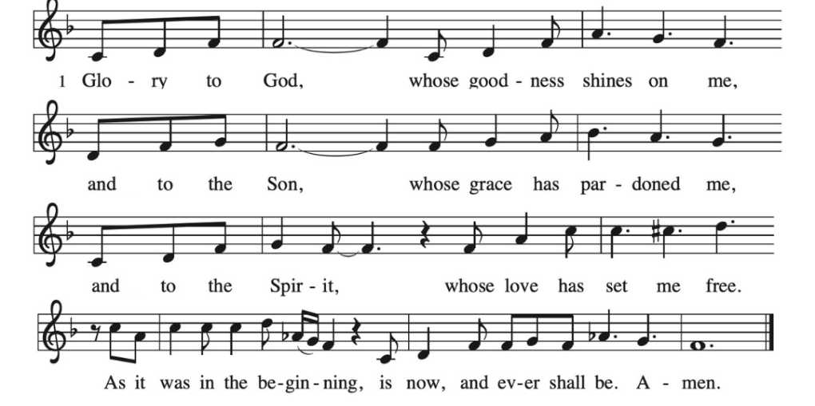

* Prayer After Communion Pastor Tina and congregation

Sustaining God, with this bread and cup, you nourish us with mercy and abundant life. By your Spirit, send us from this table to serve a needy world. Make us living signs of your liberation, healing, and love, following the way of Jesus, in whose name we pray. Amen.

*A Word from Artist and Pastor Paul Oman

* Blessing Pastor Tina

* Closing Hymn "Savior, Like a Shepherd Lead Us" ELW 789
Public Domain
1.Savior like a shepherd lead us; much we need your tender care. In your pleasant pastures feed us, for our use your fold prepare. Blessed Jesus, blessed Jesus, you have bought us; we are yours. Blessed Jesus, blessed Jesus, you have bought us we are yours.

2.We are yours, in love befriend us, be the guardian of our way; keep your flock, from sin defend us, seek us when we go astray. Blessed Jesus, blessed Jesus, hear us children when we pray.
Blessed Jesus, blessed Jesus, hear us children when we pray.

3.You have promised to be receive us, poor and sinful though we be; you have mercy to relieve us, grace to cleanse, and pow’r to free. Blessed Jesus, blessed Jesus, early let us turn to you.
Blessed Jesus, blessed Jesus, early let us turn to you.

4.Early let us seek your favor, early let us do your will; blessed Lord and only Savior, with your love our spirits fill. Blessed Jesus, blessed Jesus, you have loved us, love us still. Blessed
Jesus, blessed Jesus, you have loved us, love us still.

* Dismissal
Go out in joy. Be led forth in peace. Thanks be to God!

*Postlude

Please Note:
A reception will immediately follow in the community center.

All are welcome.

++Artist Paul ohman has given permission for his painting to be broadcast onto our video.++

