
Holy Trinity Evangelical Lutheran Church

7th Sunday After Pentecost

July 12, 2026, at 10:30 am

Pastor Tina Crog

*Prelude

* Welcome and Announcements Worship Assistant

* Opening Hymn "Open Now Thy Gates of Beauty" ELW 533
Public Domain vs. 1, 2, 4, 5
1.Open now thy gates of beauty, Zion, let me enter there,
where my soul in joyful duty waits for God who answers prayer.
Oh, how blessed is this place, filled with solace, light and grace!

2.Gracious God, I come before thee; come thou also unto me;
where we find thee and adore thee, there a heav’n on earth must be. To my heart, oh, enter thou, let it be thy temple now!

4.Thou my faith increase and quicken, let me keep thy gift divine;
how-so-e’er temptations thicken, nay thy word still o’er me shine
as my guiding star through life, as my comfort in all strife.

5.Speak, O God, and I will hear thee, let thy will be done indeed;
may I undisturbed draw near thee while thou dost thy people feed. Here of life the fountain flows; here is balm for all our woes.

* Confession and Forgiveness Pastor Tina
Blessed be the holy Trinity, ☩ one God, who calls us by name, claims us as family, and keeps covenant with us through every generation. Amen.

Trusting in God’s mercy, let us confess our sin. Silence is kept for reflection.

God of Abraham and Hagar, you have called us into your family by grace, not by earning. Yet we forget who we belong to. We trust our own striving more than your promise. We cling to favoritism, resentment, fear, and scarcity. We wound one another in word and deed. We doubt your provision, resist your calling, and turn away from our neighbors. Forgive us. Remind us whose we are. Teach us to live as people shaped by your covenant of mercy; through Jesus Christ, our Lord. Amen.

Hear the good news: God’s promise does not depend on human perfection. The covenant is gift, not reward. Your past does not define you; God’s mercy does. In the name of Jesus Christ, your sins are forgiven. Amen.

*Greeting Pastor Tina
*Prayer of the Day Worship Assistant
Almighty God, we thank you for planting in us the seed of your word. By your Holy Spirit help us to receive it with joy, live according to it, and grow in faith and hope and love, through Jesus Christ, our Savior and Lord. Amen.

*Children’s Moment Pastor Tina

*Passing of the Peace Worship Assistant
May the peace of christ be with you always. and also with you.

share the peace of christ with one another with a wave.

*First Lesson: Genesis 25:19-34 Reader
¹⁹ These are the descendants of Isaac, Abraham’s son: Abraham was the father of Isaac, ²⁰ and Isaac was forty years old when he married Rebekah, daughter of Bethuel the Aramean of Paddan-aram, sister of Laban the Aramean. ²¹ Isaac prayed to the Lord for his wife because she was barren, and the Lord granted his prayer, and his wife Rebekah conceived. ²² The children struggled together within her, and she said, “If it is to be this way, why do I live?” So she went to inquire of the Lord. ²³ And the Lord said to her,
“Two nations are in your womb,
and two peoples born of you shall be divided;
the one shall be stronger than the other;
the elder shall serve the younger.”
²⁴ When her time to give birth was at hand, there were twins in her womb. ²⁵ The first came out red, all his body like a hairy mantle, so they named him Esau. ²⁶ Afterward his brother came out, with his hand gripping Esau’s heel, so he was named Jacob. Isaac was sixty years old when she bore them.
²⁷ When the boys grew up, Esau was a skillful hunter, a man of the field, while Jacob was a quiet man, living in tents. ²⁸ Isaac loved Esau because he was fond of game, but Rebekah loved Jacob.
²⁹ Once when Jacob was cooking a stew, Esau came in from the field, and he was famished. ³⁰ Esau said to Jacob, “Let me eat some of that red stuff, for I am famished!” (Therefore he was called Edom.) ³¹ Jacob said, “First sell me your birthright.” ³² Esau said, “I am about to die; of what use is a birthright to me?” ³³ Jacob said, “Swear to me first.” So he swore to him and sold his birthright to Jacob. ³⁴ Then Jacob gave Esau bread and lentil stew, and he ate and drank and rose and went his way. Thus Esau despised his birthright.
The Word of the Lord. Thanks be to God.

*Psalmody “How Long Will You Forget Me Lord" Psalm 13
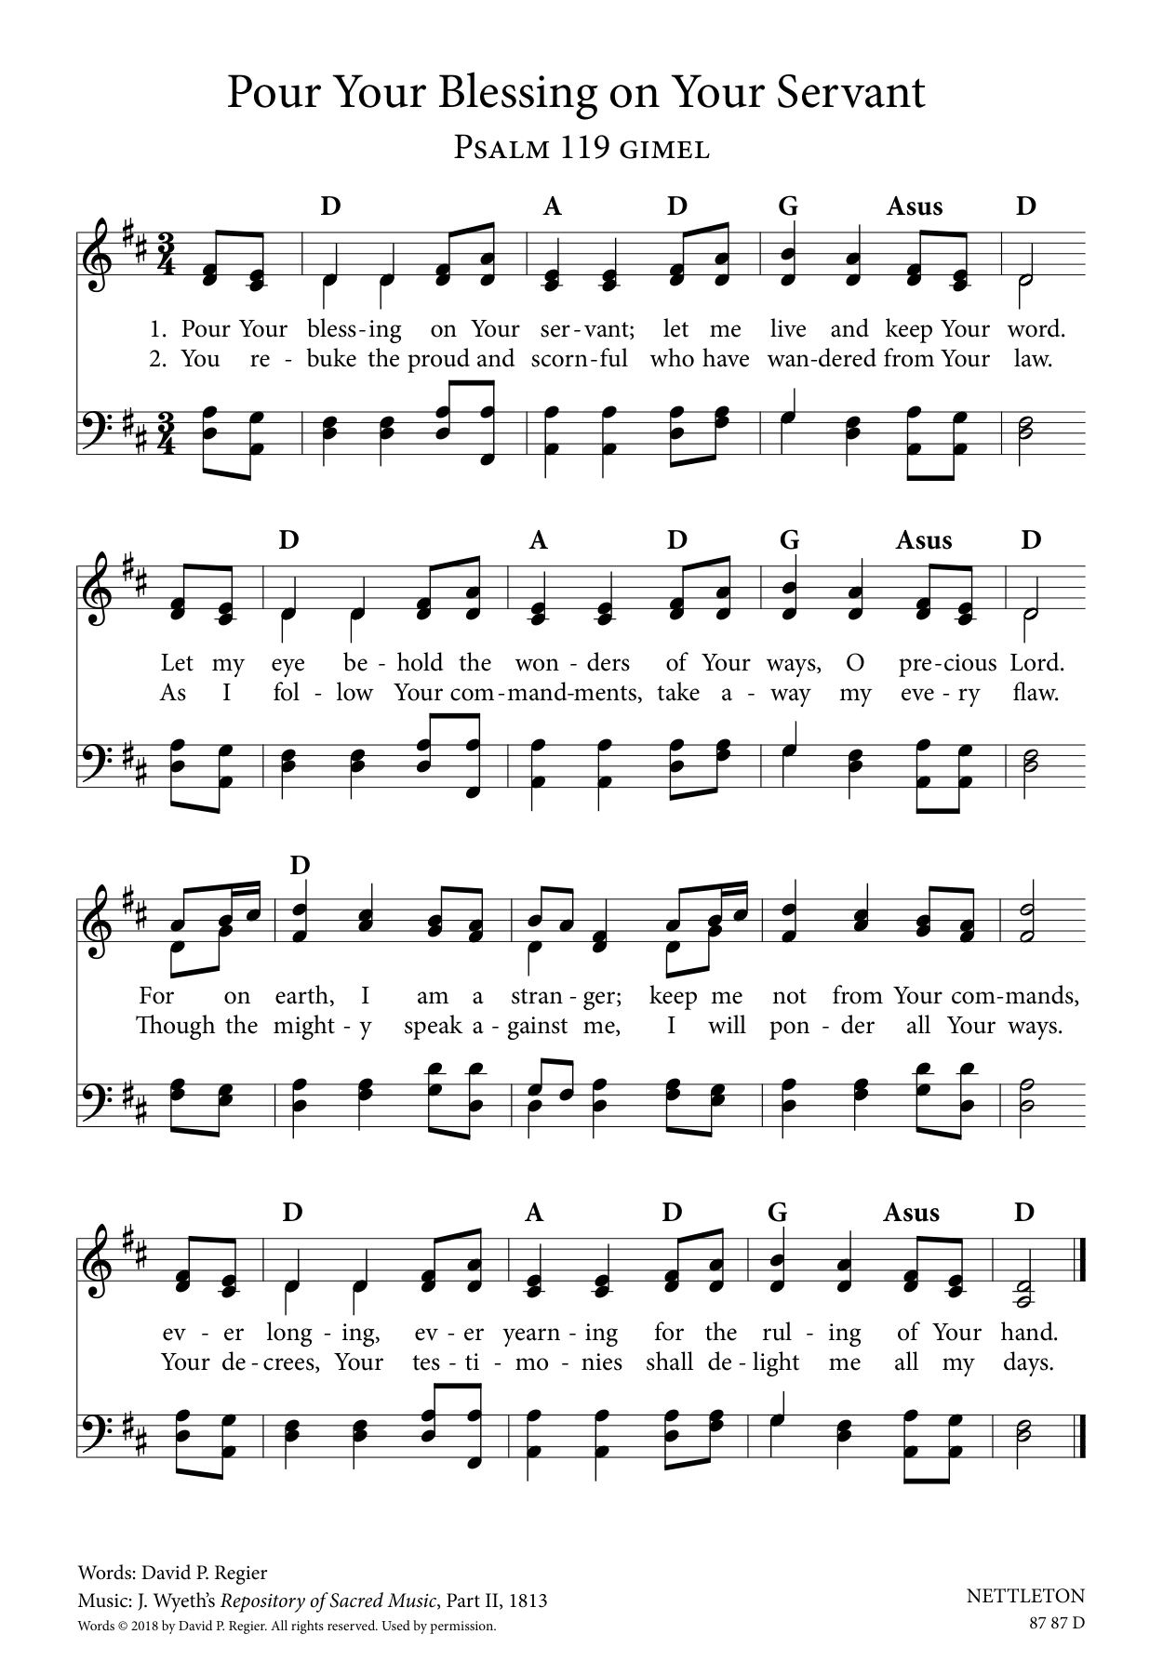

* Gospel Acclamation “Word of Life, Jesus Christ” WOV pg. 48
Word of Life, Jesus Christ, All Glory to You!
Word of Life, Jesus Christ, All Glory to You!
Our hearts burn within us while you open to us the Scriptures.
Word of Life, Jesus Christ, All Glory to You!
Word of Life, Jesus Christ, All Glory to You!
* Gospel: Matthew 13:1-9, 18-23 Pastor Tina
The Holy Gospel according to Matthew, the 13th chapter. Glory to you, O Lord.

¹ That same day Jesus went out of the house and sat beside the sea. ² Such great crowds gathered around him that he got into a boat and sat there, while the whole crowd stood on the beach. ³ And he told them many things in parables, saying: “Listen! A sower went out to sow. ⁴ And as he sowed, some seeds fell on a path, and the birds came and ate them up. ⁵ Other seeds fell on rocky ground, where they did not have much soil, and they sprang up quickly, since they had no depth of soil. ⁶ But when the sun rose, they were scorched, and since they had no root, they withered away. ⁷ Other seeds fell among thorns, and the thorns grew up and choked them. ⁸ Other seeds fell on good soil and brought forth grain, some a hundredfold, some sixty, some thirty. ⁹ If you have ears, hear!”
¹⁸ “Hear, then, the parable of the sower. ¹⁹ When anyone hears the word of the kingdom and does not understand it, the evil one comes and snatches away what is sown in the heart; this is what was sown on the path. ²⁰ As for what was sown on rocky ground, this is the one who hears the word and immediately receives it with joy, ²¹ yet such a person has no root but endures only for a while, and when trouble or persecution arises on account of the word, that person immediately falls away. ²² As for what was sown among thorns, this is the one who hears the word, but the cares of this age and the lure of wealth choke the word, and it yields nothing. ²³ But as for what was sown on good soil, this is the one who hears the word and understands it, who indeed bears fruit and yields in one case a hundredfold, in another sixty, and in another thirty.”

The Gospel of the Lord. Praise to you, O Christ.

Sermon Pastor Tina

* Hymn of the Day "Arise Your Light Has Come” ELW 314
Public Domain
1.Arise, your light has come! The Spirit’s call obey;
show forth the glory of your God which shines on you today.

2.Arise, your light has come! Fling wide the prison door;
proclaim the captive’s liberty, good tidings to the poor.

3.Arise, your light has come! All you in sorrow born,
bind up the broken-hearted ones and comfort those who mourn.

4.Arise, your light has come! The mountains burst in song!
Rise up like eagles on the wing, God’s pow’r will make us strong.

* Apostle’s Creed Worship Assistant
Let us proclaim our faith in the words of the apostle’s creed.
I believe in God, the Father almighty,
creator of heaven and earth.
I believe in Jesus Christ, God's only Son, our Lord,
who was conceived by the power of the Holy Spirit,
born of the Virgin Mary,
suffered under Pontius Pilate,
was crucified, died, and was buried;
he descended to the dead.
On the third day he rose again;
he ascended into heaven,
he is seated at the right hand of the Father,
and he will come to judge the living and the dead.
I believe in the Holy Spirit,
the holy catholic Church,
the communion of saints,
the forgiveness of sins,
the resurrection of the body,
and the life everlasting. Amen.

* Prayers of Intercession Pastor Tina
Be Seated
Prayer Requests or Joys to Share
Gathered together by the Holy Spirit, let us pray for the church and the needs of the world. A brief silence.

God our gardener, you scatter grace like seed across the world. Continue to cultivate the garden of your church with your abundant Spirit. God of grace, hear our prayer.
God our joy, your bountiful creation reflects your commitment to life despite our actions disregarding its wonder. We look toward Isaiah’s vision, when all creation rejoices, and the trees will clap for joy at your salvation. God of grace, hear our prayer.

God our life, you give us the same Spirit by which you raised Christ from the dead. Set our minds on that Spirit whenever fear or condemnation overwhelm throughout the world. God of grace, hear our prayer.

God our host and table, we pray for children who hunger and rely on school meals, for all who toil under the hot sun without refreshment, for the chronically ill who have exhausted their resources, and for local concerns (especially). God of grace, hear our prayer.

God our source, tend this assembly with your grace throughout this summer season. May those who travel for work or recreation do so safely, and may visitors find refreshment among us. God of grace, hear our prayer.

We give you thanks that the roots of your goodness run deep throughout history. We remember those saints who have gone before us in faith. God of grace, hear our prayer.

Trusting you receive all our prayers, we commend our spoken and unspoken prayers to you, O God, through Jesus our Savior. Amen.

*Offering Worship Assistant
The monthly mission for july is “School Supplies.” Let us give to god what He has first given us.

* Offering Music by Jared

* Offering Hymn “Glory to You” WOV Service of Word
Pentecost Verse
Glory to You, God for Yours is the Earth;
Yours the Anointing,The Radiant Worth.
Ours the Rejoicing for Spirits Aflame;
Ours the Thanksgiving to Your Holy Name.
Ours be the Telling of Deeds Greatly Done;
Yours be the Glory, O God, Yours Alone.

* Offering Prayer Worship Assistant and congregation
Loving God, we offer at your table the gifts of our hearts. Help us take heart in you and share freely of your love, so that all creation can taste your abundance. We ask this in the name of Jesus, through the Spirit abiding with us now and forever. Amen.

*The Great Thanksgiving (spoken) Pastor Tina
The Lord be with you.
And also with you.
Lift up your hearts,
We lift them to the Lord.
Let us give thanks to the Lord, our God.
It is right to give God our thanks and praise.

*Eucharistic Prayer and Words of Institution Pastor Tina
* Lord’s Prayer
Our Father, who art in heaven, hallowed be thy name, thy
kingdom come, thy will be done, on earth as it is in heaven.
Give us this day our daily bread; and forgive us our trespasses,
as forgive those who trespass against us; and lead us not into
temptation, but deliver us from evil. For thine is the kingdom,
and the power, and the glory, forever and ever. amen.
Special Music during Holy Communion by Jared

*Post Communion Blessing

* Post Communion Hymn “Praise God from Whom All Blessings Flow” Public Domain ELW 884
Praise God, from whom all blessings flow;
Praise God, all creatures here below;
Praise God, ye heav’nly host;
Praise Father, Son, and Holy Ghost.

* Prayer After Communion Pastor Tina and Congregation
Compassionate God, through the gifts of bread and wine our hearts are filled with the abundance of your love. Strengthen us that we, through this holy meal, may share your love freely, as you have shared with us. We ask this in the name of Jesus, through the Spirit nourishing us now and forever. Amen.

* Blessing Pastor Tina

* Closing Hymn "O Living Bread from Heaven" ELW 542
Public Domain
1.O living Bread from heaven, how well you feed your guest!
The gifts that you have given have filled my heart with rest.
O wondrous food of blessing! O cup that heals our woes!
My heart, this gift possessing, in thankful song o’er-flows!

2.My Savior, you have led me within your holiest place, and here yourself have fed me with treasures of your grace;
for you have freely given what earth could never buy,
the bread of life from heaven, that now I shall not die.

3.You gave me all I wanted; this food can death destroy.
And you have freely granted the cup of endless joy.
My Lord, I do not merit the favor you have shown,
and all my soul and spirit bow down before your throne.

4. Oh, grant me then, well strengthened with heav’nly food, while
here my course on earth is lengthened, to serve you, free from fear; and bring me home to praise you where none can peace destroy, where I will ever raise you glad songs in endless joy.

* Dismissal Worship Assistant
Go in peace, sharing the gifts of Christ! Thanks be to God!

*Postlude

