Holy Trinity Evangelical Lutheran Church

March 8, 2026, at 10:30 am

Third Sunday of Lent

Lay Speaker, Bill Pim

*Prelude

* Welcome and Announcements Worship Assistant

*Opening Hymn “Faith of Our Fathers” ELW #812
Public Domain

1.Faith of our fathers, living still in spite of dungeon, fire and
sword. Oh, how our hearts beat high with joy whene’er we
hear that glorious word. Faith of our father, holy faith, we will
be true to you till death.

2.The martyrs, chained in prison dark, were still in heart and
conscience free; and blest would be their children’s fate if
they, like them, should die for thee. Faith of our fathers, holy
faith, we will be true to you till death.

3.Faith of our fathers! We will love both friend and foe in all our
strife; proclaim thee too, as love knows how, by saving word
and faithful life. Faith of our fathers, holy faith, we will be true
to you till death.

* Confession and Forgiveness Bill Pim
Blessed be the holy Trinity, ☩ one God, who forgives all our sin, whose mercy endures forever. Amen.

Let us confess our sin before God, who removes our guilt and blots out all offenses.

God of generations, you place us within families, communities, and stories larger than ourselves. Yet we confess how often we resist humility. We grow impatient with one another, ignore wisdom that challenges us, and withhold mercy when it is hardest to offer. Clinging to our own way, we struggle to trust your call to gentleness. Forgive our sins. Teach us the strength of meekness and the freedom that mercy brings. In the name of Jesus, we pray. Amen.

Hear the good news: God does not give up on what God has made. and God’s grace reshapes our relationships. In Christ, you are forgiven, ☩ and sent to live as salt and light in the world. Amen.

* Canticle of Praise “Hear Our Prayer” ELW 178
One License – A-700000
Hear our prayer, hear our prayer, Lord, make us whole:
Peace to all people, hope for each soul.
God of grace, in this place, hear our prayer.

*Greeting Bill Pim
The Grace of our lord, Jesus Christ, the love of god and the communion of the holy spirit be with you. and also with you.

*Prayer of the Day Worship Assistant and Congregation
God of steadfast love, you gather us into households and neighborhoods where we are shaped by one another. Form in us gentle strength and compassionate hearts, so that mercy guides our actions and our living reflects your work of reconciliation; through Jesus Christ, our Savior and Lord. Amen.

* Passing of the Peace Worship Assistant
may the peace of christ be with you always. and also with you.
Please share the peace of christ with one another with a wave,
then wave to those watching from their home.

*Children’s Moment- pulpit prequel Bill Pim

*First Lesson: Ruth 1:1-18 Reader
¹ In the days when the judges ruled, there was a famine in the land, and a certain man of Bethlehem in Judah went to live in the country of Moab, he and his wife and two sons. ² The name of the man was Elimelech and the name of his wife Naomi, and the names of his two sons were Mahlon and Chilion; they were Ephrathites from Bethlehem in Judah. They went into the country of Moab and remained there. ³ But Elimelech, the husband of Naomi, died, and she was left with her two sons. ⁴ These took Moabite wives; the name of the one was Orpah and the name of the other Ruth. When they had lived there about ten years, ⁵ both Mahlon and Chilion also died, so that the woman was left without her two sons and her husband.
⁶ Then she started to return with her daughters-in-law from the country of Moab, for she had heard in the country of Moab that the Lord had considered his people and given them food. ⁷ So she set out from the place where she had been living, she and her two daughters-in-law, and they went on their way to go back to the land of Judah. ⁸ But Naomi said to her two daughters-in-law, “Go back each of you to your mother’s house. May the Lord deal kindly with you, as you have dealt with the dead and with me. ⁹ The Lord grant that you may find security, each of you in the house of your husband.” Then she kissed them, and they wept aloud. ¹⁰ They said to her, “No, we will return with you to your people.” ¹¹ But Naomi said, “Turn back, my daughters. Why will you go with me? Do I still have sons in my womb that they may become your husbands? ¹² Turn back, my daughters, go your way, for I am too old to have a husband. Even if I thought there was hope for me, even if I should have a husband tonight and bear sons, ¹³ would you then wait until they were grown? Would you then refrain from marrying? No, my daughters, it has been far more bitter for me than for you, because the hand of the Lord has turned against me.” ¹⁴ Then they wept aloud again. Orpah kissed her mother-in-law goodbye, but Ruth clung to her.
¹⁵ So she said, “Look, your sister-in-law has gone back to her people and to her gods; return after your sister-in-law.” ¹⁶ But Ruth said,
“Do not press me to leave you,
to turn back from following you!
Where you go, I will go;
where you lodge, I will lodge;
your people shall be my people
and your God my God.
¹⁷ Where you die, I will die,
and there will I be buried.
May the Lord do thus to me,
and more as well,
if even death parts me from you!”
¹⁸ When Naomi saw that she was determined to go with her, she said no more to her.

The Word of the Lord. Thanks be to God.

*Second Lesson: Ephesians 6:1-4 Reader
¹ Children, obey your parents in the Lord, for this is right. ² “Honor your father and mother”—this is the first commandment with a promise ³ “so that it may be well with you and you may live long on the earth.”
⁴ And, fathers, do not provoke your children to anger, but bring them up in the discipline and instruction of the Lord.

The Word of the Lord. Thanks be to God.

* Acclamation “Remember That You are Dust” ACS 919
One License A-700000

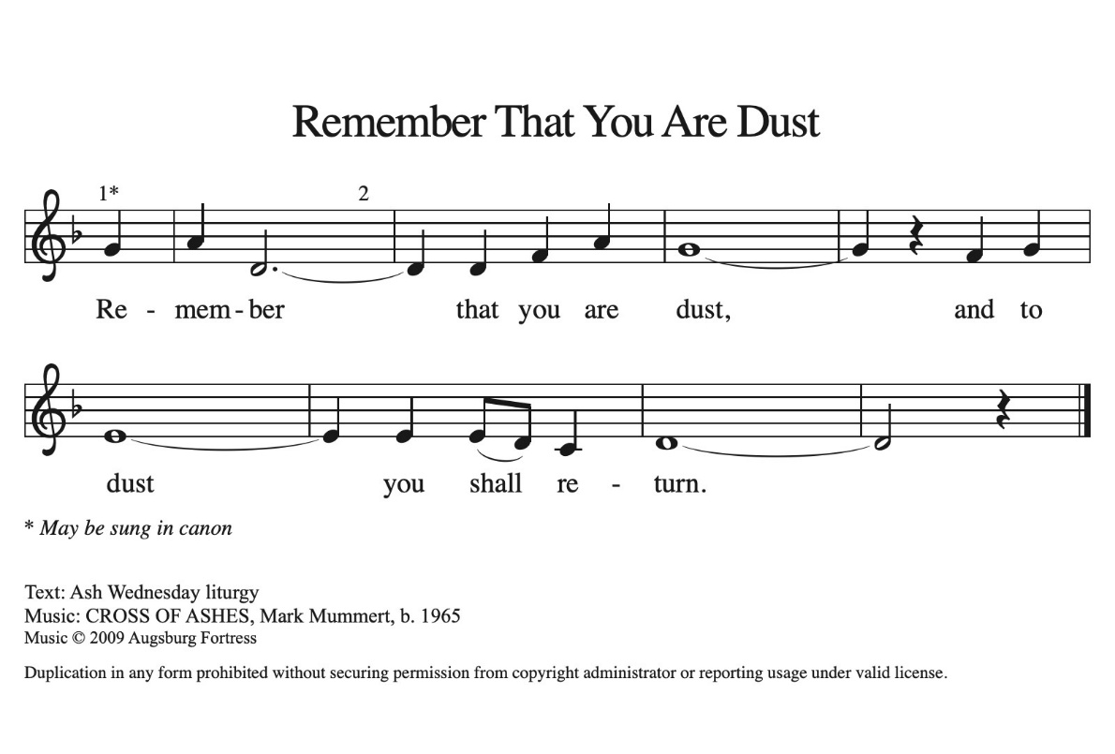

* Gospel: Matthew 21:23-31 Bill Pim
The Holy Gospel according to Matthew, the 21st chapter. Glory to you, O Lord.
²³ When he entered the temple, the chief priests and the elders of the people came to him as he was teaching and said, “By what authority are you doing these things, and who gave you this authority?” ²⁴ Jesus said to them, “I will also ask you one question; if you tell me the answer, then I will also tell you by what authority I do these things. ²⁵ Did the baptism of John come from heaven, or was it of human origin?” And they argued with one another, “If we say, ‘From heaven,’ he will say to us, ‘Why, then, did you not believe him?’ ²⁶ But if we say, ‘Of human origin,’ we are afraid of the crowd, for all regard John as a prophet.” ²⁷ So they answered Jesus, “We do not know.” And he said to them, “Neither will I tell you by what authority I am doing these things.
²⁸ “What do you think? A man had two sons; he went to the first and said, ‘Son, go and work in the vineyard today.’ ²⁹ He answered, ‘I will not,’ but later he changed his mind and went. ³⁰ The father went to the second and said the same, and he answered, ‘I go, sir,’ but he did not go. ³¹ Which of the two did the will of his father?” They said, “The first.” Jesus said to them, “Truly I tell you, the tax collectors and the prostitutes are going into the kingdom of God ahead of you.
The Gospel of the Lord. Praise to you, O Christ.

*Sermon “Become Your Parents” Bill Pim

* Hymn of the Day “Eternal Father, Strong to Save” ELW 756
Public Domain

1.Eternal Father, strong to save, whose arm has bound the
rest-less wave, who bade the mighty ocean deep its own
appointed limits keep: oh, hear us when we cry to thee for
those in peril on the sea.

2.O Savior, whose almighty word the winds and waves
submissive heard, who walked upon the foaming deep, and
calm amid the storm didst sleep: Oh, hear us when we cry
to thee for those in peril on the sea.

3.O Holy Spirit, who didst brood upon the chaos dark and rude,
and bid its angry tumult cease, and give, for wild confusion,
peace: Oh, hear us when we cry to thee for those in peril on the
sea.

4. O Trinity of love and pow’r, all trav’lers guard in danger’s hour
from rock and tempest, fire and foe, protect them wheresoe’er
they go; thus evermore shall rise to thee glad hymns and
praise from land and sea.

* Apostle’s Creed Worship Assistant
Let us proclaim our faith in the words of the Apostle’s creed.
I believe in God, the Father almighty,
creator of heaven and earth.
I believe in Jesus Christ, God's only Son, our Lord,
who was conceived by the power of the Holy Spirit,
born of the Virgin Mary,
suffered under Pontius Pilate,
was crucified, died, and was buried;
he descended to the dead.
On the third day he rose again;
he ascended into heaven,
he is seated at the right hand of the Father,
and he will come to judge the living and the dead.
I believe in the Holy Spirit,
the holy catholic Church,
the communion of saints,
the forgiveness of sins,
the resurrection of the body,
and the life everlasting. Amen.

* Prayers of Intercession Bill Pim
Be seated
prayer requests or shares of joy
Reconciled by God’s mercy and sustained by God’s presence, let us pray for the world and its needs.

O God, when suffering arises, preserve your church. Give to pastors, deacons, bishops, and all servants of your gospel the endurance that produces character and the hope that will never disappoint. Hear us, O God. Your mercy is great.

When the waters run dry, sustain this earth. Send water to places languishing with drought, and bring relief to places damaged by floods. Hear us, O God. Your mercy is great.

When quarrels ensue, soften our hearts. Quell hostilities between nations and peoples, and reconcile all humans across the lines of race, class, nationality, moral conviction, religion, and all else that divides or oppresses. Hear us, O God. Your mercy is great.

When your people thirst, satisfy their needs. Send water and food to all who need nourishment. Grant welcome to all who are excluded. Show your mercy to any in need (especially). Hear us, O God. Your mercy is great.
When we gather to worship, send us your Spirit. Renew our hearts through the joyful noise we make and bless the work of our church musicians and musical ensembles (especially). Hear us, O God. Your mercy is great.

O God, when death draws near, we rejoice in the promise of life with you. We remember all who have entered eternal rest, and we pray that you bring us the hope of sharing in your glory. Hear us, O God. Your mercy is great.

Receive our prayers, O God, through Jesus Christ, our strength and salvation.
Amen.

*Offering Worship Assistant
The monthly mission for march is for “the altar guild repairs.”
Let us give to god what he has first given us.

*Offering Special Music by Jared

* Offering Hymn “Create in Me a Clean Heart” ELW #188
Public Domain
Create in me a clean heart, O God, and renew a right spirit within
me. Cast me not away from your presence, and take not your
holy Spirit from me. Restore unto me the joy of your salvation,
and uphold me with your free Spirit.

* Offering Prayer Worship Assistant and Congregation
Faithful God, you have given us all that we are and all that we have. Receive these gifts as signs of our trust and use them for your work in the world. Form our lives in humility, mercy, and love, that we may bear witness to your kingdom; through Jesus Christ, our Savior and Lord. Amen.

* Lord’s Prayer Bill Pim ELW pg.145
Gathered into one by the Holy Spirit, Let us pray as Jesus taught us to pray.
Our Father, who art in heaven, hallowed be thy name, thy kingdom come, thy will be done, on earth as it is in heaven.
Give us this day our daily bread; and forgive us our trespasses,
as we forgive those who trespass against us; and lead us not into temptation, but deliver us from evil. For thine is the kingdom, and the power, and the glory, forever and ever. Amen.

* Blessing Bill Pim
Receive the blessing of the holy Trinity:
God, who calls all things into existence,
Jesus Christ, who redeems us,
and the Holy Spirit, whose breath sustains creation,
☩ bless you now and always.
Amen.

*Hymnology Story Bill Pim

* Closing Hymn “Jesus, Keep Me Near the Cross” ELW #335
Public Domain
1.Jesus, keep me near the cross, there’s a precious fountain;
free to all, a healing stream flows from Calv’ry’s mountain.
In the cross, in the cross be my glory ever: till my ransomed
soul shall find rest beyond the river.

2. Near the cross, a trembling soul, love and mercy found me;
there the bright and morning star sheds its beams around me.
In the cross, in the cross be my glory ever: till my ransomed
soul shall find rest beyond the river.

3.Near the cross! O Lamb of God, bring its scenes before me;
help me walk from day to day with its shadow o’er me.
In the cross, in the cross be my glory ever: till my ransomed
soul shall find rest beyond the river.

4. Near the cross I’ll watch and wait, hoping, trusting ever, till
I reach the golden strand just beyond the river.
In the cross, in the cross be my glory ever: till my ransomed
soul shall find rest beyond the river.

* Dismissal Worship Assistant
Go in peace. Go in peace. Believe the good news.
Thanks be to God!

*Postlude

