Holy Trinity Lutheran Church

February 22, 2026, at 10:30 am

First Sunday of Lent

Lay Speaker, Bill Pim

*Prelude

* Welcome and Announcements Worship Assistant

*Opening Hymn “O Lord, Throughout These Forty Days” ELW #319
One License A-700000

1.O Lord, through out these forty days you prayed and kept the fast; inspire repentance for our sin, and free us from our past.

2.You strove with Satan, and you won; your faithfulness endured; lend us your nerve, your skill and trust in God’s eternal
word.

3.Though parched and hungry, yet you prayed and fixed your mind above; so teach us to deny ourselves that we know God’s love.

4.Be with us through this season, Lord, and all our earthly days,
that when the final Easter dawns, we join in heaven’s praise.

* Confession and Forgiveness Bill Pim
Blessed be the holy Trinity, ☩ one God, who forgives all our sin, whose mercy endures forever. Amen.

Let us confess our sin before God, who removes our guilt and blots out all offenses.

God of promise, you brought your people out of slavery and called them to trust you alone. Yet we confess that we cling to other gods— to productivity instead of rest, to control instead of trust, to our own strength instead of your grace. We rush past Sabbath rest and live as though everything depends on us. Forgive us, O God. Help us to admit our need for you. In the name of Christ, we pray. Amen.

Hear the good news: God does not give up on what God has made and God’s grace reshapes our relationships. In Christ, you are forgiven, ☩ and sent to live as salt and light in the world. Amen.

* Canticle of Praise “Hear Our Prayer” ELW 178
One License A-700000

Hear our prayer, hear our prayer, Lord, make us whole:
Peace to all people, hope for each soul.
God of grace, in this place, hear now our prayer.

*Greeting Bill Pim
The Grace of our Lord, Jesus Christ, the Love of God and the communion of the Holy Spirit be with you all. and also with you.

*Prayer of the Day worship assistant
Holy and faithful God, you brought your people out of bondage and gave your law as a gift of life. Teach us to trust you alone, to honor your holy name, and to rest in your grace. Help us to receive the kingdom you freely give; through Jesus Christ, our Savior and Lord. Amen.

* Passing of the Peace worship assistant
may the peace of christ be with you always. and also with you.

Share the peace of christ with one another with a wave. then turn and wave to everyone watching the live service at home.

Children’s Moment pulpit prequel Bill Pim
First Lesson: Exodus 19:1–8; 20:1–11 Reader
¹ On the third new moon after the Israelites had gone out of the land of Egypt, on that very day, they came into the wilderness of Sinai. ² They journeyed from Rephidim, entered the wilderness of Sinai, and camped in the wilderness; Israel camped there in front of the mountain. ³ Then Moses went up to God; the Lord called to him from the mountain, “Thus you shall say to the house of Jacob and tell the Israelites: ⁴ ‘You have seen what I did to the Egyptians and how I bore you on eagles’ wings and brought you to myself. ⁵ Now, therefore, if you obey my voice and keep my covenant, you shall be my treasured possession out of all the peoples. Indeed, the whole earth is mine, ⁶ but you shall be for me a priestly kingdom and a holy nation.’ These are the words that you shall speak to the Israelites.”
⁷ So Moses went, summoned the elders of the people, and set before them all these words that the Lord had commanded him. ⁸ The people all answered as one, “Everything that the Lord has spoken we will do.” Moses reported the words of the people to the Lord.

¹ Then God spoke all these words,
² “I am the Lord your God, who brought you out of the land of Egypt, out of the house of slavery; ³ you shall have no other gods before me.
⁴ “You shall not make for yourself an idol, whether in the form of anything that is in heaven above or that is on the earth beneath or that is in the water under the earth. ⁵ You shall not bow down to them or serve them, for I the Lord your God am a jealous God, punishing children for the iniquity of parents to the third and the fourth generation of those who reject me ⁶ but showing steadfast love to the thousandth generation of those who love me and keep my commandments.
⁷ “You shall not make wrongful use of the name of the Lord your God, for the Lord will not acquit anyone who misuses his name.
⁸ “Remember the Sabbath day and keep it holy. ⁹ Six days you shall labor and do all your work. ¹⁰ But the seventh day is a Sabbath to the Lord your God; you shall not do any work—you, your son or your daughter, your male or female slave, your livestock, or the alien resident in your towns. ¹¹ For in six days the Lord made heaven and earth, the sea, and all that is in them, but rested the seventh day; therefore, the Lord blessed the Sabbath day and consecrated it.
The Word of the Lord. Thanks be to God.

Second Lesson: Matthew 5:1–12 Reader
¹ When Jesus saw the crowds, he went up the mountain, and after he sat down, his disciples came to him. ² And he began to speak and taught them, saying:
³ “Blessed are the poor in spirit, for theirs is the kingdom of heaven.
⁴ “Blessed are those who mourn, for they will be comforted.
⁵ “Blessed are the meek, for they will inherit the earth.
⁶ “Blessed are those who hunger and thirst for righteousness, for they will be filled.
⁷ “Blessed are the merciful, for they will receive mercy.
⁸ “Blessed are the pure in heart, for they will see God.
⁹ “Blessed are the peacemakers, for they will be called children of God.
¹⁰ “Blessed are those who are persecuted for the sake of righteousness, for theirs is the kingdom of heaven.
¹¹ “Blessed are you when people revile you and persecute you and utter all kinds of evil against you falsely on my account. ¹² Rejoice and be glad, for your reward is great in heaven, for in the same way they persecuted the prophets who were before you

The Word of the Lord. Thanks be to God.

* Acclamation “Remember That You are Dust” ACS 919
One License A-700000

Musician plays the melody through one time. Congregation joins in the second time.
Please include the music on the slide.
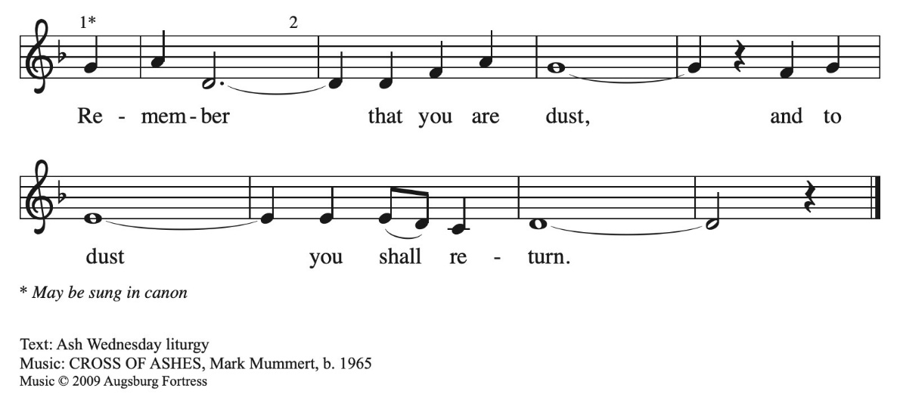

* Gospel: Matthew 6:1-6, 16-18 Lay Speaker, Bill Pim
The Holy Gospel according to Matthew, the 6th chapter. Glory to you, O Lord.
1”Beware of practicing your righteousness before others in order to be seen by them, for then you have no reward from your Father in heaven. 2 “So whenever you give alms, do not sound a trumpet before you, as the hypocrites do in the synagogues and in the streets, so that they may be praised by others. Truly I tell you, they have reached their reward. 3 But when you give alms, do not let your left hand know what your right hand is doing, 4 so that your alms may be done in secret, and your Father who sees in secret will reward you.
5 “And whenever you pray, do not be like the hypocrites, for they love to stand and pray in the synagogues and at the street corners, so that they may be seen by others. Truly I tell you, they have received their reward. 6 But whenever you pray, go into your room and shut the door and pray to your Father who is in secret, and your Father who sees in secret will reward you.
18 “And whenever you fast, do not look somber, like the hypocrites, for they mark their faces to show others that they are fasting. Truly I tell you, they have received their reward. 17 But when you fast, put oil on your head and wash your face, 18 so that your fasting may be seen not by others but by your Father who is in secret, and your Father who sees in secret will reward you.
The Gospel of the Lord. Praise to you, O Christ.
Sermon “Thou Shalt” Lay Speaker, Bill Pim

* Hymn of the Day “When We are Tested" ACS 922
One License A-700000
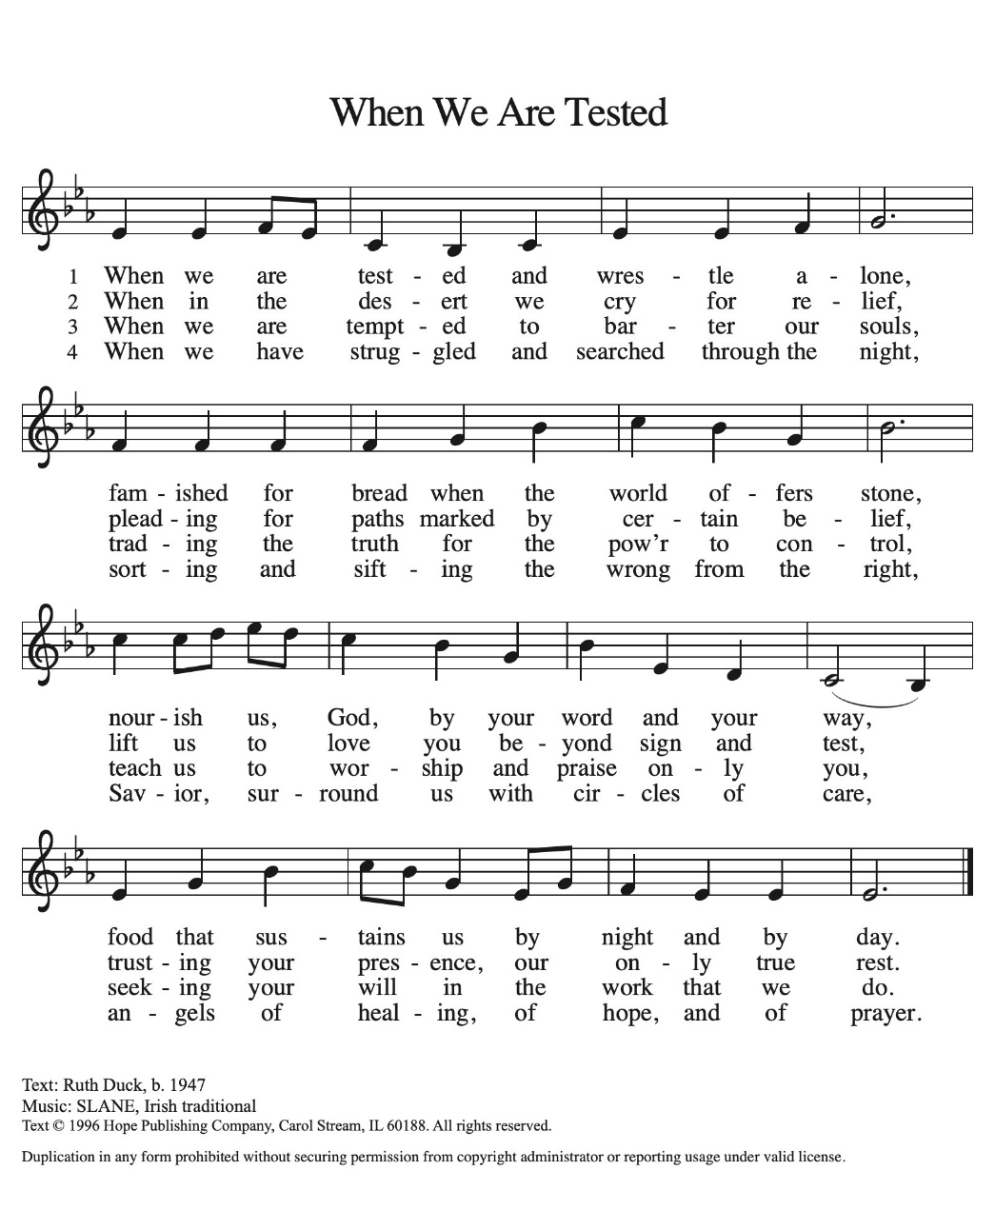

* Apostle’s Creed Worship Assistant
let us proclaim our faith in the words of the apostle’s creed.
I believe in God, the Father almighty,
creator of heaven and earth.
I believe in Jesus Christ, God's only Son, our Lord,
who was conceived by the power of the Holy Spirit,
born of the Virgin Mary,
suffered under Pontius Pilate,
was crucified, died, and was buried;
he descended to the dead.
On the third day he rose again;
he ascended into heaven,
he is seated at the right hand of the Father,
and he will come to judge the living and the dead.
I believe in the Holy Spirit,
the holy catholic Church,
the communion of saints,
the forgiveness of sins,
the resurrection of the body,
and the life everlasting. Amen.

* Prayers of Intercession bill pim
be seated
any prayer request or joys to share
Reconciled by God’s mercy and sustained by God’s presence, let us pray for the world and its needs.

God of all grace, grant faith to your church. Give to all the baptized the will to resist temptation and to worship and serve you alone. Hear us, O God. Your mercy is great.

God of all creation, tend this earth. When human greed and disobedience threaten this planet and the life it contains, lead us by your Spirit into ways of reverence, awe, and gentleness. Hear us, O God. Your mercy is great.

God of all nations, preserve us from trouble. Surround all living in places of violence with your steadfast love and give resilience to all who work for peace. Hear us, O God. Your mercy is great.

God of all healing, mend our wounds. Bring wholeness to all who are sick, give peace to all who groan in grief, and send companions to all who are lonely or isolated. (Especially we pray for . . .) Hear us, O God. Your mercy is great.

God of all people, provide for our community. For any among us who hunger for bread, bring nourishment. For any among us who hunger for truth, speak your life-giving word. Hear us, O God. Your mercy is great.

God of all life, bring us to you. We thank you for your free and abounding grace, and for those who, by that same grace, now rest eternally in you (especially). Hear us, O God. Your mercy is great.

Receive our prayers, O God, through Jesus Christ, our strength and salvation. AMEN.

Offering Worship assistant
the monthly mission for february is for “fellowship.” let us give to god what he has first given us.

Offering special Music by Jared

* Offering Hymn “Create in Me a Clean Heart” ELW #188
To be sung while the offering is being returned to the Altar.
Public Domain
Create in me a clean heart, O God, and renew a right spirit within
Me. Cast me not away from your presence, and take not your Holy Spirit from me. Restore unto me the joy of your salvation,
And uphold me with your free Spirit.

* Offering Prayer worship assistant and congregation
Faithful God, you have given us all that we are and all that we have. Receive these gifts as signs of our trust and use them for your work in the world. Form our lives in humility, mercy, and love, that we may bear witness to your kingdom; through Jesus Christ, our Savior and Lord. Amen.

* Lord’s Prayer ELW pg.145
gathered into one by the holy spirit, let us pray as jesus taught us to pray.

our father, who art in heaven, hallowed be thy name, thy kingdom come, thy will be done, on earth as it is in heaven. give us this day our daily bread; and forgive us our trespasses, as we forgive those who trespass against us; and lead us not into
temptation, but deliver us from evil. for thine is the kingdom,
and the power, and the glory, forever and ever. amen.

* Blessing Bill Pim
Receive the blessing of the holy Trinity:
God, who calls all things into existence,
Jesus Christ, who redeems us,
and the Holy Spirit, whose breath sustains creation,
☩ bless you now and always.
Amen.

Hymnology story Bill Pim
Be seated

* Closing Hymn “God Be with you till we meet again” ELW 536
Public Domain

1.God be with you till we meet again; by good counsels guide, uphold you, with a shepherd’s care enfold you; God be with you till we meet again. Till we meet, till we meet, till we meet at Jesus’
feet; till we meet, till we meet, God be with you till we meet again.

2.God be with you till we meet again; holy wings securely hide you, daily manna still provide you; God be with you till we meet
again. Till we meet, till we meet, till we meet at Jesus’ feet; till we
meet, till we meet, God be with you till we meet again.

3.God be with you till we meet again; when life’s perils thick
confound you, put unfailing arms around you; God be with you
till we meet again. Till we meet, till we meet, till we meet at Jesus’ feet; till we meet, till we meet, God be with you till we meet again.

* Dismissal worship assistant
Go in peace. Go in peace. Believe the good news.
Thanks be to God!

*Postlude

